Spam Detection Using NLP Techniques
Zihan Wang
Introduction
Spam detection is essential in managing the overwhelming influx of unsolicited messages in modern communication systems. This project applies machine learning techniques to classify SMS messages as either spam or non-spam. By exploring various algorithms and feature engineering methods, this project demonstrates the power of natural language processing and machine learning in tackling real-world problems.

Methodology
Data Preparation
- Dataset: SMS Spam Collection Dataset with 5,572 entries, reduced to 5,169 after removing duplicates.
- Cleaning: Non-essential columns were removed. Missing and duplicate values were handled appropriately.
- Encoding: Label encoding was used for the target column (ham as 0 and spam as 1).
Feature Engineering
- Added columns for:
  - Character count
  - Word count
  - Sentence count
Text Preprocessing
- Steps:
  - Lowercasing
  - Tokenization
  - Removing stop words and special characters
  - Stemming
Visualization
- Word clouds and histograms highlighted key differences in the vocabulary and structure between spam and non-spam messages. Just like the two pictures below: the left is word cloud for only Spam words, the right is for only non-spam words. 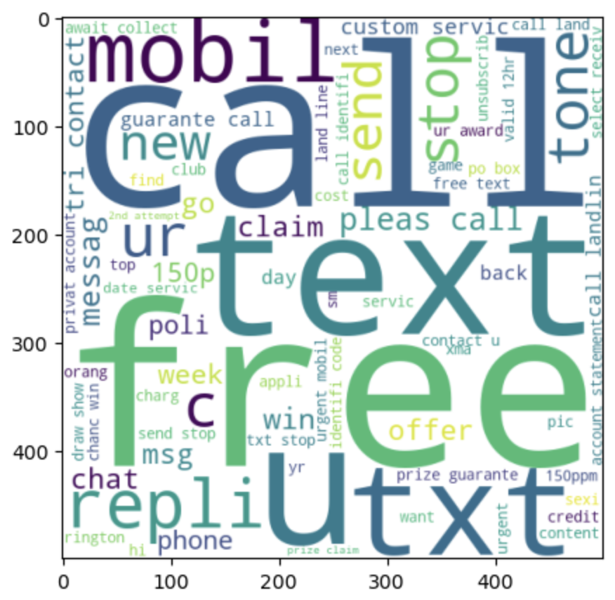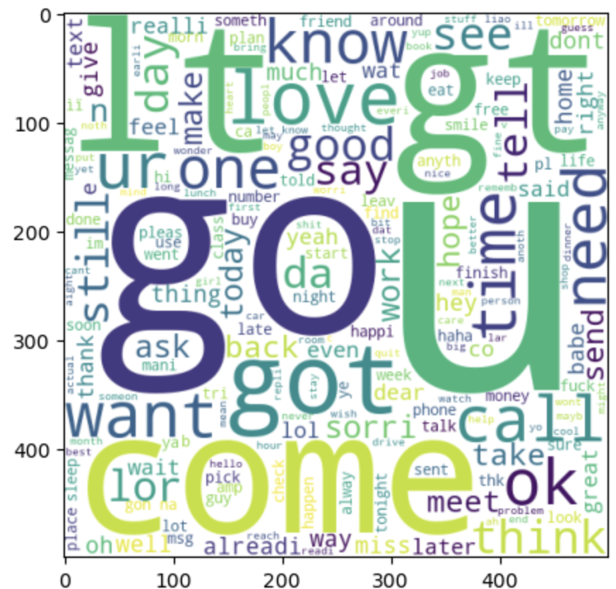
Models and Algorithms
Vectorization
- Bag of Words (BoW): Represented text as word frequency vectors.
- #implement BOW vectorization on our text
- #taking most frequent 5000 words from the vocabulary
- from sklearn.feature_extraction.text import CountVectorizer
- cv = CountVectorizer()
- TF-IDF (Term Frequency-Inverse Document Frequency): Highlighted important terms by balancing term frequency and rarity.
Algorithms
- Naive Bayes Variants:
  - GaussianNB
  - MultinomialNB
  - BernoulliNB
- Other Classifiers:
  - Logistic Regression
  - Decision Trees
  - SVM
  - Random Forest
  - Gradient Boosting and others
- # Create different classifier models
- svc = SVC(kernel='sigmoid', gamma=1.0) # Support Vector Classifier with sigmoid kernel
- knc = KNeighborsClassifier() # K-Nearest Neighbors Classifier
- mnb = MultinomialNB()
- dtc = DecisionTreeClassifier(max_depth=5) # Decision Tree Classifier with maximum depth of 5
- lrc = LogisticRegression(solver='liblinear', penalty='l1') # Logistic Regression Classifier with L1 regularization
- rfc = RandomForestClassifier(n_estimators=50, random_state=2) # Random Forest Classifier with 50 decision trees
- abc = AdaBoostClassifier(n_estimators=50, random_state=2) # AdaBoost Classifier with 50 weak learners
- bc = BaggingClassifier(n_estimators=50, random_state=2) # Bagging Classifier with 50 base estimators
- etc = ExtraTreesClassifier(n_estimators=50, random_state=2) # Extra Trees Classifier with 50 decision trees
- gbdt = GradientBoostingClassifier(n_estimators=50, random_state=2) # Gradient Boosting Classifier with 50 boosting stages
- xgb = XGBClassifier(n_estimators=50, random_state=2) # XGBoost Classifier with 50 boosting rounds
Results
Evaluation Metrics
- Precision was prioritized to minimize false positives in spam detection.
- Accuracy was also calculated for comparison.
Key Findings
- Multinomial Naive Bayes with TF-IDF achieved:
  - Accuracy: 97.09%
  - Precision: 100%
- Bernoulli Naive Bayes with TF-IDF had slightly lower performance:
  - Accuracy: 98.35%
  - Precision: 99.18%
- Other models like SVM and Random Forest performed well but fell short of Naive Bayes in precision.
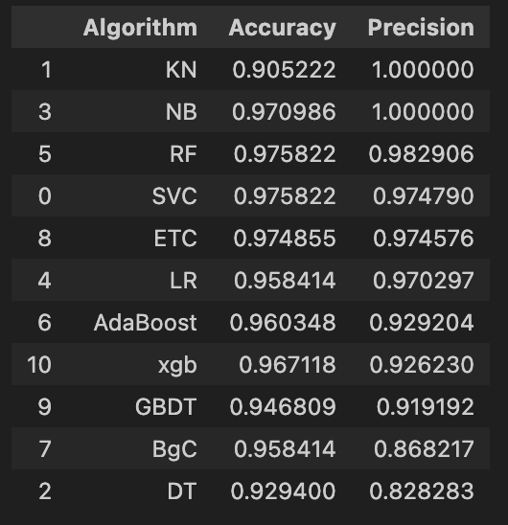
Discussion
Advantages
- Naive Bayes is computationally efficient, making it ideal for real-time applications.
- TF-IDF enhanced feature representation, improving model precision.
Limitations
- High reliance on the quality of the preprocessing and vectorization pipeline.
- Imbalanced dataset (more non-spam messages) may impact recall.
Future Work
- Expand Dataset: Incorporate more diverse and updated spam datasets.
- Deep Learning Models: Experiment with LSTM or Transformer models for contextual understanding.
- Real-Time Testing: Deploy the system in a live environment to assess robustness.
- Hybrid Approaches: Combine Naive Bayes with other models for enhanced recall.
Conclusion
This project successfully demonstrates the effectiveness of machine learning, particularly Naive Bayes with TF-IDF vectorization, in classifying spam messages. The approach is robust, interpretable, and efficient, achieving state-of-the-art precision in the context of the chosen dataset.

Works Cited
- Kaggle SMS Spam Collection Dataset
- Documentation for sklearn and NLTK libraries
- Tutorials on TF-IDF and Naive Bayes on Kaggle

